

**Dr. BABASAHEB AMBEDKAR MARATHWADA UNIVERSITY, AURANGABAD**

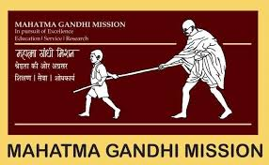

**MGM’S**

**Dr. G. Y. Pathrikar College of Computer Science & Information Technology, Aurangabad -431003**

**(2019-2020)**

**Project Report**

**On**

**“Medical Billing Management System”**

**In partial fulfillment of requirement for the degree of Bachelor of Computer Science**

**Submitted By-**

**Nikhil Rajendra Borse**

**Guided By -**

**Dr. Yogesh Rajput sir**



**Dr. BABASAHEB AMBEDKAR MARATHWADA UNIVERSITY, AURANGABAD**



**MGM’S**

**Dr. G.Y. Pathrikar College of Computer Science & Information Technology, Aurangabad – (431003)**

**‘CERTIFICATE'**

This is to certify that, **Nikhil Rajendra Borse** have successfully completed the project report on “Medical Billing System” for partial fulfillment of course B.Sc. (Computer Science) Sixth Semester, affiliated to Dr. BabasahebAmbedkarMarathwada University, Aurangabad, during the Academic year( 2019-2020).

**Roll no: - (A0193007)**

**Project Guide Head of Department**

**Dr. Yogesh Rajput Dr. S. Azade**

**Examiner**